

AN EXPLAINABLE AND DRIFT-AWARE MLOPS PIPELINE FOR HEART DISEASE PREDICTION USING AWS EC2, AMAZON S3, AND AMAZON CLOUDWATCH

AIM23CL302 - ML Models on Cloud (ML Ops)

Submitted by

SHREEJAA SUBRAMANIAN MURUGESAN – E0124014
HARI PRIYA J – E0124026

In partial fulfillment for the award of the degree of
BACHELOR OF TECHNOLOGY
in
COMPUTER SCIENCE AND ENGINEERING
(Artificial Intelligence and Machine Learning)

Sri Ramachandra Faculty of Engineering and Technology, Sri Ramachandra Institute of Higher Education and Research, Porur, Chennai -600116

NOVEMBER, 2026

BONAFIDE CERTIFICATE

We, SHREEJAA SUBRAMANIAN MURUGESAN (E0124014) and HARI PRIYA J (E0124026), hereby declare that the project report entitled “AN EXPLAINABLE AND DRIFT-AWARE MLOPS PIPELINE FOR HEART DISEASE PREDICTION USING AWS EC2, AMAZON S3, AND AMAZON CLOUDWATCH” is submitted under the guidance of Prof. Ms. Rhevathi for AIM23CL302 – ML Models on Cloud Laboratory, at Sri Ramachandra Faculty of Engineering and Technology, in partial fulfilment of the requirements for the fifth semester of the third-year B.Tech. degree programme in the Department of Computer Science and Engineering during the academic year 2026–2027

Prof. Ms. RHEVATHI M
Course faculty,
Assistant Professor,
Sri Ramachandra Faculty of Engineering and Technology, Sri Ramachandra Institute of Higher Education and Research, Porur, Chennai, Tamil Nadu.

Submitted for the ML Models on Cloud Laboratory project presentation held at Sri Ramachandra Faculty of Engineering and Technology on -------------------

Internal Examiner External Examiner

TABLE OF CONTENTS

CHAPTER NO. | TITLE | PAGE NO.
 | ABSTRACT | 4
1 | INTRODUCTION AND RESEARCH GAP  - Background & Motivation  - Related Work MatriX | 5
2 | SYSTEM ARCHITECTURE & AWS METHODOLOGY  - Pipeline Architecture Diagram  - Data Ingestion & Lineage Control  - Continuous Training (CT) Orchestration  - Serverless Inference Microservice Deployment  - Automated Monitoring & Drift Loop | 8
3 | EXPERIMENTAL SETUP & RESULTS | 13
4 | CONCLUSION & FUTURE ENHANCEMENTS | 16
5 | REFERENCES | 17

ABSTRACT

Heart disease is one of the major health concerns worldwide, and early identification of potential heart disease risk can support timely medical evaluation. Machine learning techniques can assist in analyzing patient health information and identifying patterns associated with heart disease. However, developing a machine learning model alone is not sufficient for a practical application. The model must also be deployed, monitored, and maintained to ensure reliable operation in a production environment.

This project presents an Explainable and Drift-Aware MLOps Pipeline for Heart Disease Prediction that integrates machine learning, cloud computing, model explainability, and automated monitoring components. The system uses an Explainable Boosting Machine (EBM) as the primary prediction model and Logistic Regression as a baseline model for performance comparison. The models are trained and evaluated using a heart disease dataset. Performance is measured using accuracy, precision, recall, F1-score, ROC-AUC, and cross-validation.

The trained EBM model is serialized in SKOPS format and stored in Amazon Simple Storage Service (Amazon S3). MLflow is used to track experiments, model parameters, evaluation metrics, and artifacts. The model is deployed on an Amazon EC2 instance using FastAPI, which provides prediction and explainability APIs. A web application developed using HTML, CSS, and JavaScript allows users to enter patient information and obtain prediction results with associated probabilities and explanations.

The system also incorporates production monitoring using Evidently AI to detect data drift by comparing incoming production data with reference data. Prediction inputs, outputs, probabilities, and timestamps are recorded for monitoring purposes. A minimum of 30 production records is required before drift analysis is performed, and a 20% drift threshold is used to determine whether an alert should be generated. Amazon CloudWatch is integrated to collect and monitor application logs, while Amazon Simple Notification Service (SNS) sends email notifications when significant data drift is detected.

The proposed system demonstrates an end-to-end MLOps workflow that combines heart disease prediction, explainability, cloud deployment, experiment tracking, and production data monitoring. It provides a structured approach to deploying and monitoring machine learning applications in a cloud environment.

Keywords: Heart Disease Prediction, Machine Learning, Explainable Boosting Machine, Logistic Regression, MLOps, FastAPI, Amazon S3, Amazon EC2, MLflow, Evidently AI, Data Drift Detection, Amazon CloudWatch, Amazon SNS.

CHAPTER 1 INTRODUCTION & RESEARCH GAP
Heart disease is a significant global health concern, creating a need for reliable prediction systems that can assist in the early identification of potential health risks. Machine learning techniques have become increasingly useful in healthcare data analysis because they can identify patterns in patient health parameters and use those patterns to generate predictions. However, developing an accurate machine learning model is only one part of building a practical prediction system. Deploying the model, monitoring its behaviour, maintaining its supporting infrastructure, and identifying changes in incoming data are also important for its continued operation.
This project presents a machine learning-based Heart Disease Prediction System integrated with Machine Learning Operations (MLOps) practices. The system uses a trained machine learning model to predict the likelihood of heart disease from patient health parameters. A Streamlit web application provides an accessible interface for submitting inputs and viewing prediction results. The application is deployed on an Amazon Web Services (AWS) EC2 instance, while Amazon S3 supports the storage of machine learning model artifacts.
The project also incorporates input drift detection to identify changes in the distribution of incoming data compared with a reference dataset. The monitoring mechanism processes inputs in batches of 30 records and uses statistical tests to identify features that may have undergone significant distribution changes. Amazon CloudWatch provides centralized application logging, helping monitor operational activity and troubleshoot issues.

1.1 Background & Motivation
The increasing availability of healthcare datasets has created opportunities to apply machine learning techniques to medical prediction tasks. Heart disease prediction is one such application, in which patient characteristics and clinical measurements are analysed to estimate the likelihood of disease. A machine learning-based system can provide a structured and accessible way to generate predictions from these parameters. However, such predictions are intended to support research and analysis rather than replace professional medical diagnosis.
Traditional machine learning projects often concentrate on model development and evaluation. In a deployed environment, additional challenges arise, including application availability, artifact management, logging, and changes in the data supplied to the model. The statistical characteristics of incoming data may differ from those of the dataset used during model development. This phenomenon, known as input data drift, can indicate that the deployed system is receiving data with a different distribution from the reference data. Drift detection does not directly establish that model accuracy has decreased, but it can provide an early warning that further investigation may be necessary.
The motivation for this project is to combine heart disease prediction with essential MLOps capabilities in a cloud-based environment. AWS EC2 is used to host the Streamlit application, and Amazon S3 is used for model artifact storage. A batch-based monitoring mechanism checks incoming prediction inputs after every 30 records and records the resulting drift analysis. Amazon CloudWatch supports application log monitoring and operational troubleshooting.
By integrating these components, the project demonstrates how a machine learning application can be deployed and monitored beyond the model development stage. It provides practical experience in cloud deployment, model artifact management, input drift detection, and application logging. The resulting system serves as an educational prototype for understanding the operational requirements of machine learning applications in a healthcare-related domain.

1.2 Related Work Matrix
Existing research and development in healthcare machine learning can be grouped into several areas, including disease prediction, web-based deployment, cloud infrastructure, and data drift detection. These areas provide the technical foundation for developing a more complete machine learning system.

S. No. | Research Area | Common Approach | Limitations or Challenges | Relevance to the Proposed Project
1 | Machine Learning for Heart Disease Prediction | Applying classification algorithms to patient health parameters to predict the likelihood of heart disease. | Prediction quality depends on dataset quality, feature selection, model evaluation, and data representativeness. | Provides the predictive component of the proposed system.
2 | Web-Based Machine Learning Applications | Integrating trained models with web interfaces that accept user inputs and display predictions. | A functional interface alone does not provide comprehensive model monitoring or operational logging. | Streamlit provides the interface for submitting patient parameters and viewing predictions.
3 | Cloud-Based Model Deployment | Hosting machine learning applications on cloud computing infrastructure. | Deployment requires suitable configuration, artifact availability, service management, and operational maintenance. | AWS EC2 hosts the application, while Amazon S3 supports model artifact storage.
4 | Input Drift Detection and MLOps Monitoring | Comparing incoming data distributions with reference data using statistical tests and monitoring application logs. | Drift detection requires suitable reference data and careful interpretation; detected drift does not necessarily indicate reduced model accuracy. | The project combines batch-based drift detection with Amazon CloudWatch logging.

Research Gap

Although machine learning models can be developed to predict heart disease, model development alone does not address the operational requirements of a deployed application. A practical system also needs an accessible interface, reliable hosting, model artifact management, and mechanisms for monitoring changes in incoming data.
The key gap addressed by this project is the integration of these operational components into a single educational prototype for heart disease prediction. The proposed system combines machine learning-based prediction with AWS deployment, S3-based artifact storage, batch-based input drift detection, and CloudWatch logging. Rather than focusing exclusively on prediction, it demonstrates how deployment and monitoring can be incorporated into the lifecycle of a machine learning application.
The current implementation is a foundational MLOps prototype. It detects potential input distribution changes and supports operational log monitoring, but it does not automatically retrain or redeploy the model. Furthermore, detected drift does not establish a decline in predictive performance. These limitations identify opportunities for future development, including automated retraining workflows, model performance monitoring, and more extensive validation using representative healthcare data.

CHAPTER 2

SYSTEM ARCHITECTURE & AWS METHODOLOGY

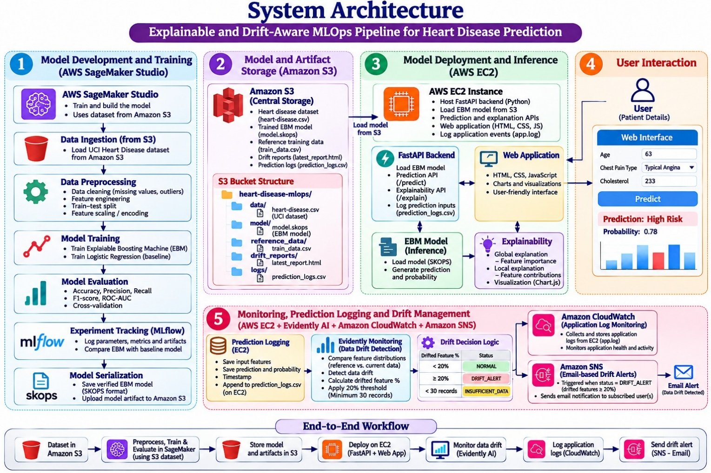
2.1 Pipeline Architecture Diagram

The proposed system follows an end-to-end MLOps architecture for heart disease prediction, integrating machine learning development, cloud-based artifact storage, model deployment, user interaction, and production monitoring. The architecture is designed to manage the complete machine learning lifecycle, from dataset ingestion to prediction and drift detection.
The pipeline consists of five major stages: model development and training, model and artifact storage, model deployment and inference, user interaction, and monitoring with prediction logging and drift management.
During the model development stage, the heart disease dataset is retrieved from Amazon Simple Storage Service (Amazon S3) and used for preprocessing and model training. Two machine learning algorithms, Explainable Boosting Machine (EBM) and Logistic Regression, are trained and evaluated. EBM is selected as the primary model based on its evaluation performance and explainability capabilities, while Logistic Regression serves as the baseline model.
MLflow is used to track experiment parameters, evaluation metrics, and model artifacts. The trained EBM model is serialized using SKOPS format and stored in Amazon S3. The EC2-hosted FastAPI application retrieves the stored model and provides prediction and explanation services.
Users interact with the system through a web interface developed using HTML, CSS, and JavaScript. Patient information is submitted to the FastAPI backend, which generates predictions using the deployed EBM model and returns the prediction results and probabilities.
The monitoring component records prediction information and uses Evidently AI to compare production data against reference data. Amazon CloudWatch collects application logs, while Amazon SNS sends email notifications when the configured data drift threshold is reached.
The architecture provides an integrated workflow connecting model development, deployment, inference, explainability, and production monitoring.

2.2 Data Ingestion & Lineage Control
Data ingestion is the initial stage of the proposed MLOps pipeline. The heart disease dataset is stored in an Amazon S3 bucket, which acts as the central storage location for the dataset and machine learning artifacts.
The dataset is retrieved from Amazon S3 and loaded into the model development environment for preprocessing and training. This approach separates dataset storage from the model development and deployment environments.
The preprocessing stage includes data cleaning, feature engineering, train-test splitting, and feature scaling and encoding. The processed dataset is then used to train the EBM and Logistic Regression models.
Amazon S3 maintains an organized structure for storing different project resources. The storage organization includes the following components:
- data/: Contains the heart disease dataset used during model development.
- model/: Stores the trained EBM model serialized in SKOPS format.
- reference_data/: Contains reference data used for production drift comparison.
- drift_reports/: Stores generated drift monitoring reports.
- logs/: Represents the prediction log storage location shown in the architecture.
MLflow supports experiment tracking by recording model parameters, performance metrics, and model artifacts. This allows the development experiments to be compared and their results to be reviewed.
The reference dataset and production prediction records are used as separate data sources during drift monitoring. Evidently AI compares their feature distributions to identify changes in incoming production data.
The combination of organized Amazon S3 storage and MLflow experiment tracking supports structured management of datasets, model artifacts, and experiment information throughout the project lifecycle.

2.3 Continuous Training (CT) Orchestration
Continuous Training (CT) refers to the process of updating machine learning models through repeated training and evaluation workflows when new data becomes available or changes in production data indicate a need for model reassessment.
In the proposed system, model development and training are performed using the heart disease dataset. The EBM and Logistic Regression algorithms are trained and evaluated using the prepared dataset. Their performance is compared using accuracy, precision, recall, F1-score, ROC-AUC, and cross-validation.
MLflow is integrated into the training workflow to record experiment parameters, evaluation metrics, and model artifacts. This supports the comparison of different model experiments and provides a record of the model development process.
After evaluation, the EBM model is selected as the primary prediction model. The selected model is serialized using SKOPS format and uploaded to Amazon S3. The stored artifact is subsequently retrieved by the EC2 deployment environment for inference.
The monitoring component also provides information that can support future model improvement. Evidently AI identifies changes in production data distributions by comparing incoming prediction records with reference data. When the configured drift threshold is reached, an alert is generated through Amazon SNS.
The detected drift information can be used as an indication that further investigation, model evaluation, and possible retraining may be required.
In the current implementation, model training and deployment are separate from the drift monitoring process. MLflow supports experiment tracking, and drift alerts provide monitoring information. However, automatic retraining and automatic model redeployment are not implemented as part of the current pipeline. These can be introduced as future enhancements to achieve a fully automated continuous training workflow.

2.4 Serverless Inference Microservice Deployment
The inference component provides prediction services through a cloud-hosted application. In this project, the trained EBM model is deployed on an Amazon EC2 instance using FastAPI as the backend framework.
The serialized model is stored in Amazon S3 and retrieved by the EC2 application during model loading. FastAPI provides endpoints that allow the frontend and external clients to communicate with the deployed machine learning model.
The major inference operations include:
- Receiving patient information through an API request.
- Validating and preparing the input features.
- Passing the processed input to the trained EBM model.
- Generating the heart disease prediction and associated probability.
- Returning the prediction response to the requesting application.
- Recording prediction information for production monitoring.
The /predict endpoint is responsible for generating predictions. The explainability functionality provides information about feature importance and individual feature contributions. The /explain/global endpoint provides global explanation functionality.
The frontend is developed using HTML, CSS, and JavaScript. It allows users to enter patient details and submit prediction requests. The FastAPI backend processes the requests and returns the results, which are displayed through the web interface using charts and visualizations.
The deployment architecture separates the user interface, backend API, and machine learning model inference functionality. This makes the application easier to maintain and allows the prediction service to be accessed through a standard API interface.
Amazon EC2 provides the computing infrastructure for hosting the application, while Amazon S3 provides centralized model artifact storage.

2.5 Automated Monitoring & Drift Loop
Production monitoring is an important component of the proposed MLOps architecture because incoming production data may differ from the data used during model development. Such changes are known as data drift and can indicate that the production environment is receiving different input patterns.
The proposed system integrates prediction logging, Evidently AI, Amazon CloudWatch, and Amazon SNS to support production monitoring and drift management.
2.5.1 Prediction Logging
Whenever a prediction request is processed, the FastAPI application records the relevant information in a CSV file named prediction_logs.csv.
The logged information includes:
- Patient input feature values.
- Generated prediction.
- Prediction probability.
- Prediction timestamp.
These records provide production data that can be used for subsequent drift analysis.

2.5.2 Data Drift Detection Using Evidently AI
Evidently AI is used to compare the distribution of reference data with the distribution of incoming production data.
The reference dataset represents the data used during model development, while the production dataset contains recorded prediction inputs.
The drift detection process performs the following operations:
- Loads the reference dataset.
- Loads the production prediction records.
- Compares the distributions of monitored features.
- Identifies features showing distribution changes.
- Calculates the percentage of drifted features.
- Generates a drift monitoring report.
A minimum of 30 production records is required before drift analysis is performed.

2.5.3 Drift Decision Logic
The system uses a configured drift threshold of 20% to determine the monitoring status.
The decision logic is described below:
Condition | Status | Description
Drifted features below 20% | NORMAL | The percentage of drifted features is below the configured threshold.
Drifted features equal to or above 20% | DRIFT_ALERT | The configured drift threshold has been reached or exceeded.
Fewer than 30 production records | INSUFFICIENT_DATA | There are not enough production records to perform drift analysis.
When the drift percentage reaches or exceeds 20%, the system generates a DRIFT_ALERT status. If fewer than 30 production records are available, the monitoring process reports INSUFFICIENT_DATA.

2.5.4 Application Monitoring Using Amazon CloudWatch
Amazon CloudWatch is integrated to monitor application logs generated by the FastAPI backend running on the EC2 instance.
The application writes log information to a local file named app.log. The CloudWatch Agent collects the application logs and forwards them to the configured Amazon CloudWatch log group.
CloudWatch provides centralized access to application activity, operational messages, and error information. This supports application monitoring and troubleshooting in the deployed environment.

2.5.5 Email Alert Notifications Using Amazon SNS
Amazon Simple Notification Service (SNS) is integrated to send email notifications when significant data drift is detected.
When the drift monitoring endpoint executes and the result returns a DRIFT_ALERT status, the application publishes a notification message to the configured SNS topic.
Amazon SNS distributes the notification to subscribed email addresses. The email alert informs users that the production data has reached the configured drift threshold and may require further investigation.

2.5.6 Overall Monitoring Workflow
The automated monitoring and drift management process connects prediction logging, drift detection, decision-making, application log monitoring, and email notification.
The FastAPI application records prediction information as users submit requests. When drift monitoring is triggered, Evidently AI compares the production prediction data with the reference dataset. The drift decision logic evaluates the percentage of drifted features against the configured threshold.
At the same time, Amazon CloudWatch collects application logs from the EC2 instance. If the drift condition reaches or exceeds the 20% threshold, Amazon SNS sends an email notification to subscribed users.
This monitoring approach helps identify changes in production data and provides visibility into application activity. It also establishes a foundation for future improvements such as scheduled drift analysis, automated retraining, and model redeployment.

CHAPTER 3

EXPERIMENTAL SETUP & RESULTS

3.1 Experimental Setup

The Heart Disease Prediction system was developed to demonstrate the integration of machine learning, cloud deployment, model explainability, and MLOps practices. The system uses an Explainable Boosting Machine (EBM) as the primary prediction model to predict the presence or absence of heart disease based on user-provided health parameters. Logistic Regression is also implemented as a baseline model to compare predictive performance.
The models were developed and evaluated using a heart disease dataset stored in Amazon Simple Storage Service (Amazon S3). MLflow was used to track experiments, model parameters, evaluation metrics, and artifacts. The selected EBM model was serialized using SKOPS format and stored in Amazon S3 for deployment.
The application is deployed on an Amazon Web Services (AWS) EC2 instance using FastAPI as the backend framework. The FastAPI application loads the trained EBM model and provides endpoints for prediction, global explanation, and drift monitoring. A web interface developed using HTML, CSS, and JavaScript allows users to enter patient details and view prediction results, probabilities, and model explanations.
The experimental setup also includes production prediction logging and data drift monitoring using Evidently AI. Prediction inputs, outputs, probabilities, and timestamps are recorded in a CSV file. The monitoring process compares production prediction data with reference data, requiring a minimum of 30 records before performing drift analysis. A 20% drift threshold is configured to determine whether a drift alert should be generated.
Amazon CloudWatch is integrated to collect application logs from the EC2 instance, while Amazon SNS is used to send email notifications when the drift status reaches the configured alert condition.

3.2 Experimental Procedure

The experiments were conducted to verify the functionality of the prediction application, model explainability, cloud deployment, and production monitoring components.
Initially, the heart disease dataset was loaded from Amazon S3 and preprocessed for model development. EBM and Logistic Regression were trained and evaluated using classification metrics such as accuracy, precision, recall, F1-score, and ROC-AUC. Cross-validation was also performed to compare model performance. Based on the evaluation results, EBM was selected as the primary model.
The selected model was serialized using SKOPS format and stored in Amazon S3. It was then loaded into the FastAPI application deployed on the EC2 instance.
Next, the prediction endpoint was tested by submitting patient health parameters through the web interface and the API documentation interface. The application processed the input values and returned the predicted class and associated probabilities.
The explainability functionality was also examined. Global feature importance was used to identify the features that have greater influence on the model's predictions, while individual prediction explanations showed the contribution of features to a particular patient's prediction.
The production monitoring mechanism was tested by generating prediction records and storing them in prediction_logs.csv. After the minimum requirement of 30 records was reached, the drift monitoring endpoint was executed. Evidently AI compared the production data with the reference dataset and calculated the percentage of drifted features.
The configured drift threshold of 20% was used to determine the monitoring status. Finally, Amazon CloudWatch was checked to verify the availability of application logs, and the Amazon SNS integration was configured to send email notifications when a DRIFT_ALERT status was generated.

3.3 Results and Observations

The experimental results demonstrated that the proposed system successfully integrated machine learning prediction, model explainability, cloud deployment, and production monitoring.
The model evaluation showed that EBM achieved an accuracy of 87.04%, while Logistic Regression achieved 85.19%. EBM also achieved higher precision, F1-score, and ROC-AUC, while both models achieved the same recall of 91.67%. Based on these results, EBM was selected as the primary model for deployment.
The deployed FastAPI application successfully processed patient input data and returned prediction results with associated class probabilities. The web interface displayed the prediction output, while the explanation component provided global feature importance and individual feature contribution visualizations.
The drift monitoring experiment was performed using 30 production prediction records. The displayed monitoring result showed a drift percentage of 0.00%, with 0 out of 13 monitored features identified as drifted. Since the measured drift percentage was below the configured 20% threshold, the monitoring status was reported as NORMAL.
Amazon CloudWatch displayed application log events, including application initialization, EBM model loading, and drift monitoring activity. The SNS integration provides an email notification mechanism for cases where the configured drift threshold is reached or exceeded.
Overall, the experimental observations demonstrate that the system can perform heart disease prediction, provide model explanations, record production predictions, and monitor changes in incoming data through an integrated AWS-based MLOps architecture.

Evaluation metric | EBM (primary model) | Logistic Regression (baseline)
Accuracy | 87.04% | 85.19%
Precision | 81.48% | 78.57%
Recall | 91.67% | 91.67%
F1-score | 86.27% | 84.62%
ROC-AUC | 90.83% | 89.86%

Comparison of Machine Learning Models

Two machine learning algorithms, Explainable Boosting Machine (EBM) and Logistic Regression, were evaluated for the heart disease prediction system. Logistic Regression was used as the baseline model, while EBM was evaluated as the primary prediction model.
The experimental results show that EBM achieved an accuracy of 87.04%, compared with 85.19% for Logistic Regression. EBM also achieved higher precision (81.48%), F1-score (86.27%), and ROC-AUC (90.83%). Both models achieved the same recall of 91.67%.
Based on these results, EBM was selected as the primary model for deployment. In addition to its stronger overall test performance, EBM provides feature-level explanations that help users understand the factors contributing to individual predictions. Logistic Regression was retained as a baseline for performance comparison.

Model Inference Latency Comparison

The following table shows the inference latency of EBM and Logistic Regression, measured in milliseconds (ms).
Latency Metric | EBM | Logistic Regression
Mean Latency | 1.016 ms | 1.047 ms
Median Latency | 0.915 ms | 0.975 ms
P95 Latency | 1.386 ms | 1.411 ms
P99 Latency | 1.517 ms | 1.623 ms

Interpretation

- Mean latency: EBM takes 1.016 ms on average, slightly faster than Logistic Regression.
- Median latency: EBM has a lower median latency of 0.915 ms.
- P95 latency: 95% of EBM inference requests complete within 1.386 ms.
- P99 latency: 99% of EBM inference requests complete within 1.517 ms.

Conclusion

EBM demonstrates slightly lower inference latency than Logistic Regression across all four reported measurements. This indicates that EBM provides marginally faster inference in the notebook's latency evaluation while also achieving better overall test-set performance.

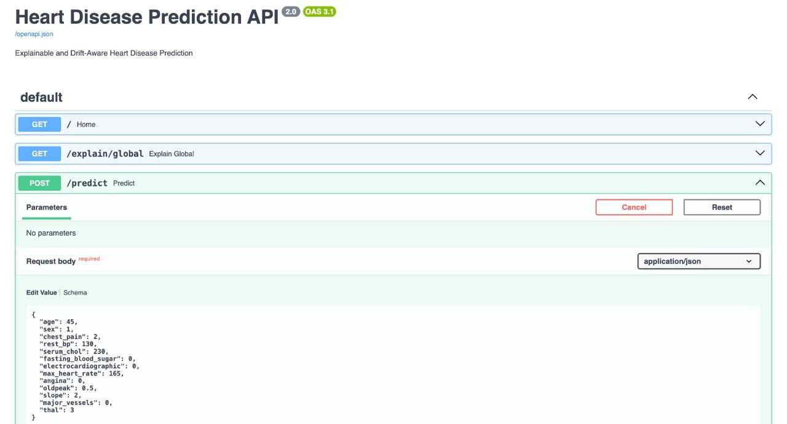

Fig. 3.1: Swagger UI documentation showing the Heart Disease Prediction API endpoints, including global explanation and patient prediction using FastAPI.

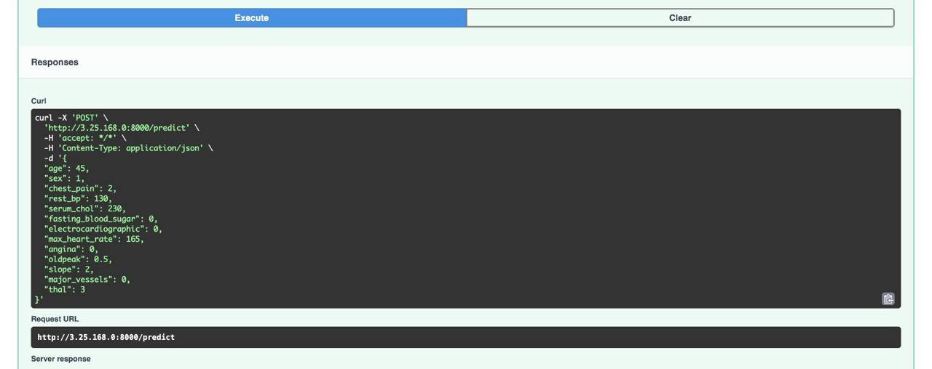

Fig. 3.2: Execution of the heart disease prediction request with patient input details submitted to the prediction endpoint.
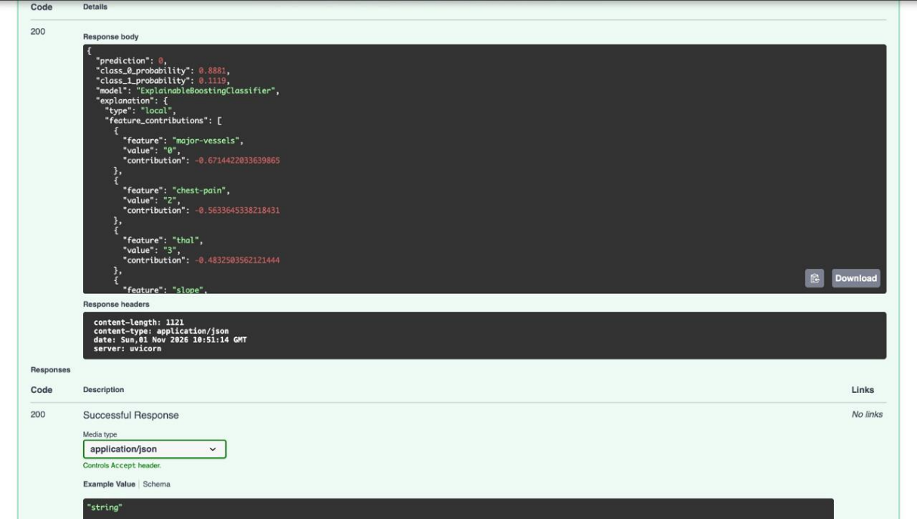

Fig. 3.3: Successful heart disease prediction response displaying the predicted class, prediction probabilities, and individual feature contributions.

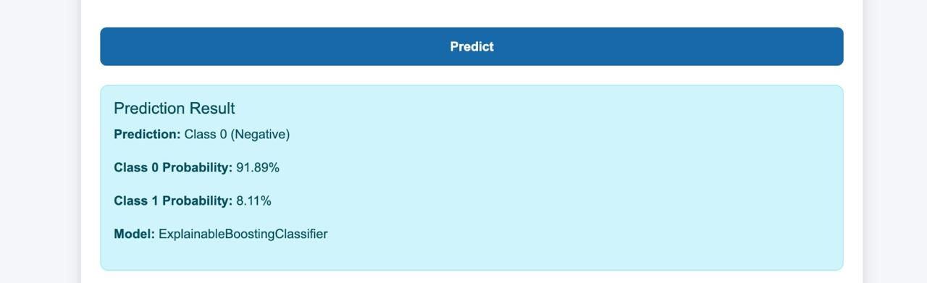

Fig. 3.4: Web application displaying the heart disease prediction result, including the predicted class, class probabilities, and selected EBM model.

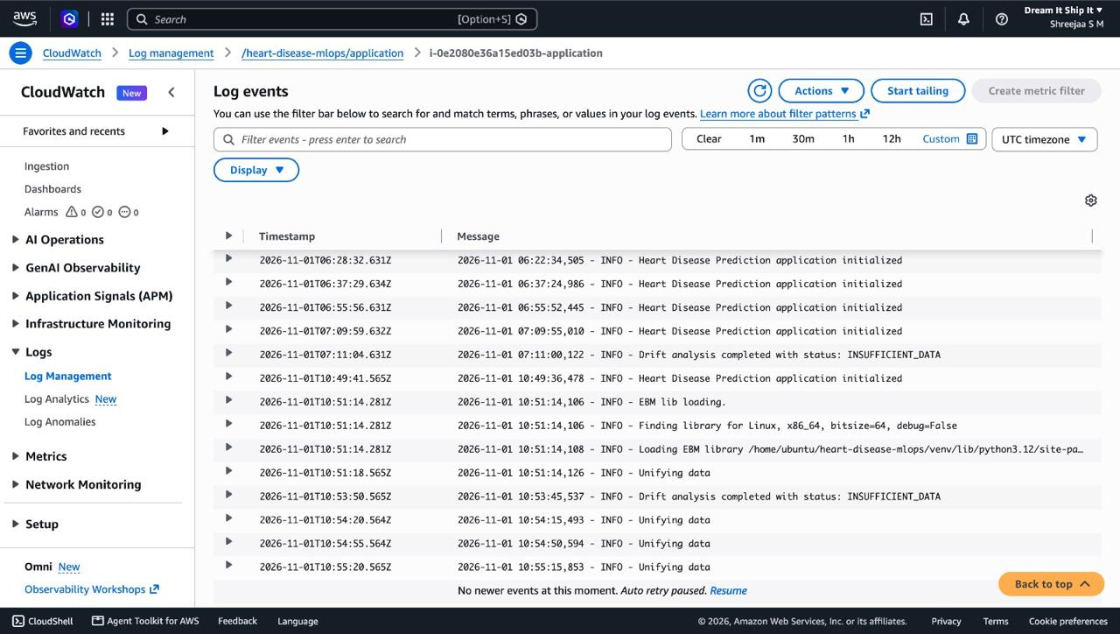

Fig. 3.5: Amazon CloudWatch log events showing application activity, EBM model loading, and Evidently AI drift monitoring results on the EC2 instance.

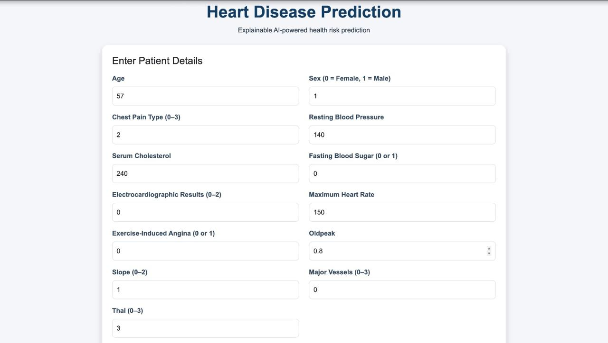

Fig. 3.6: Heart disease prediction web interface displaying the patient details input form for entering clinical attributes before generating a prediction.

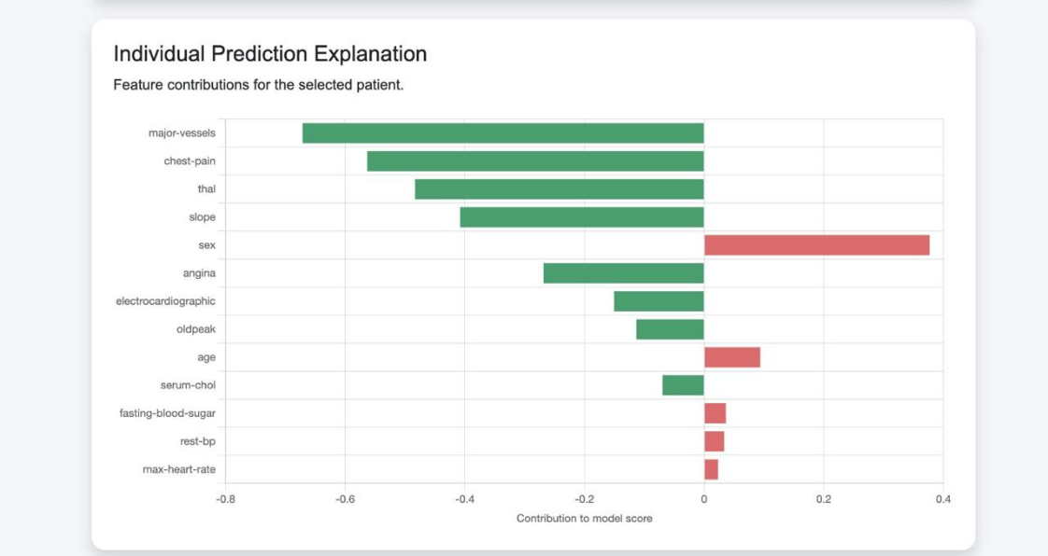

Fig. 3.7: Individual prediction explanation showing the contribution of each patient feature to the model's prediction.

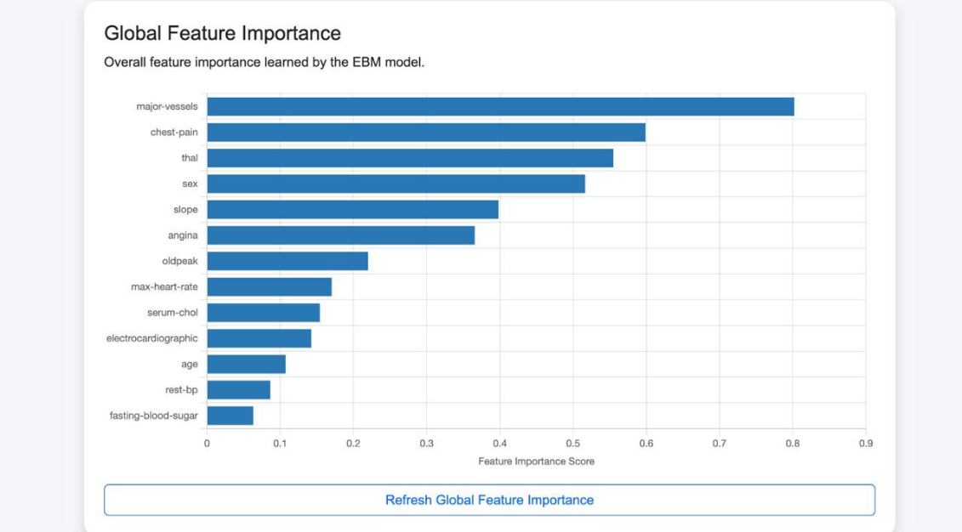

Fig. 3.8: Global feature importance chart showing the relative contribution of each feature to the EBM model's predictions.

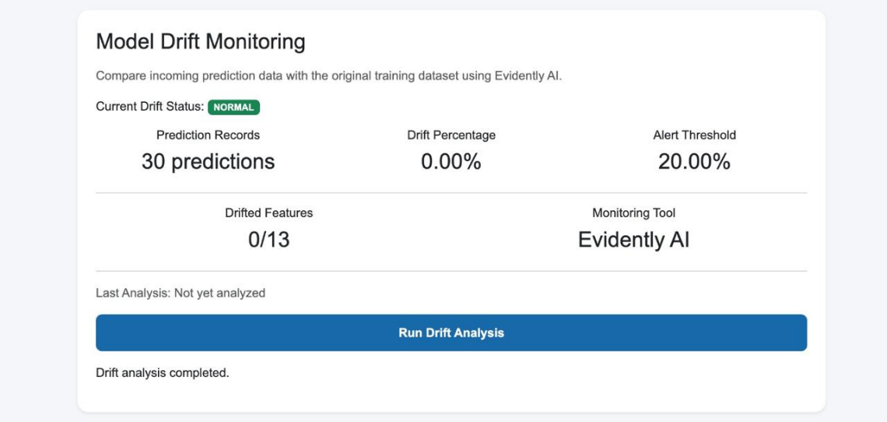

Fig. 3.9: Model drift monitoring dashboard displaying the drift status, prediction records, drift percentage, and alert
threshold using Evidently AI.

CHAPTER 4

CONCLUSION & FUTURE ENHANCEMENTS

4.1 Conclusion

The Heart Disease Prediction project successfully demonstrates the development and cloud deployment of a machine learning application integrated with basic MLOps practices. The system uses an Explainable Boosting Machine (EBM) model to predict the likelihood of heart disease based on user-provided health parameters. The Streamlit interface enables users to enter inputs, view prediction results, and understand feature importance.
The application is deployed on an AWS EC2 instance, while Amazon S3 supports model artifact storage. Amazon CloudWatch provides application log monitoring, and a batch-based drift detection mechanism analyses incoming data in batches of 30 records. Experimental testing demonstrated that the monitoring mechanism could identify deliberately introduced changes in input feature distributions.
Overall, the project integrates machine learning prediction, cloud deployment, interpretable results, model artifact management, and input drift monitoring into an educational prototype. However, the system is not a medical diagnostic tool, and detected data drift does not necessarily indicate reduced model performance. Automatic retraining and redeployment are not implemented in the current version.

4.2 Future Enhancements

The proposed system can be improved through several future developments.
- Automated Drift Monitoring: Implement scheduled or event-driven drift analysis so production data can be evaluated automatically.
- Model Retraining: Introduce a retraining workflow when significant data changes are identified and validated.
- Advanced Monitoring: Add custom application and infrastructure metrics to improve production observability.
- Enhanced Explainability: Provide more detailed visual explanations of feature contributions for individual predictions.
- Model Version Management: Introduce structured model versioning and deployment management.
- Security Improvements: Implement authentication, authorization, and secure communication for the deployed APIs.
- Expanded Dataset Evaluation: Evaluate the model using larger and more diverse datasets to assess generalization.
- Performance Optimization: Improve API response time, resource utilization, and application scalability.

CHAPTER 5

REFERENCES

- UCI Machine Learning Repository, Heart Disease Dataset. Available at: https://archive.ics.uci.edu/
- Nori, H., Jenkins, S., Koch, P., and Caruana, R., “InterpretML: A Unified Framework for Machine Learning Interpretability,” 2019.
- AWS Documentation, Amazon EC2 User Guide. Available at: https://docs.aws.amazon.com/ec2/
- AWS Documentation, Amazon Simple Storage Service (Amazon S3). Available at: https://docs.aws.amazon.com/s3/
- AWS Documentation, Amazon CloudWatch User Guide. Available at: https://docs.aws.amazon.com/AmazonCloudWatch/latest/monitoring/
- Streamlit Documentation, Streamlit API Reference and User Guide. Available at: https://docs.streamlit.io/
- Scikit-learn Documentation, Machine Learning in Python. Available at: https://scikit-learn.org/stable/
- InterpretML Documentation, Explainable Boosting Machine (EBM). Available at: https://interpret.ml/
- Sculley, D., et al., “Hidden Technical Debt in Machine Learning Systems,” Advances in Neural Information Processing Systems (NeurIPS), 2015.
- Google Cloud, Rules of Machine Learning: Best Practices for ML Engineering. Available at: https://developers.google.com/machine-learning/guides/rules-of-ml

